
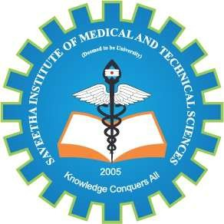
SIMATS ENGINEERING

Saveetha Institute of Medical and Technical Sciences Chennai- 602105

Student Name: A HARSHA MUKUNDHA Reg. No.: 192324070
Course Code: DSA0216 Slot: B
Course Name: Computer Vision With Opencv For Modern AI
Course Faculty: T Dr. Senthilvadivu S & Dr. Kumaragurubaran

Project Title: Examination of Brain MRI Slices to Detect Alzheimer's Disease
Module 2: Alzheimer’s Disease Detection and Classification
Module Photographs: (3 photographs –Module Photo, Individual student contribution module work in the project and presentation image)
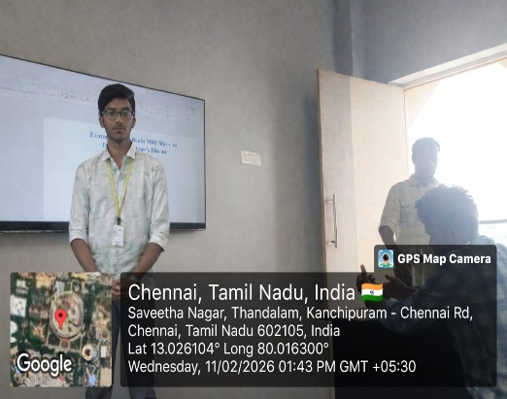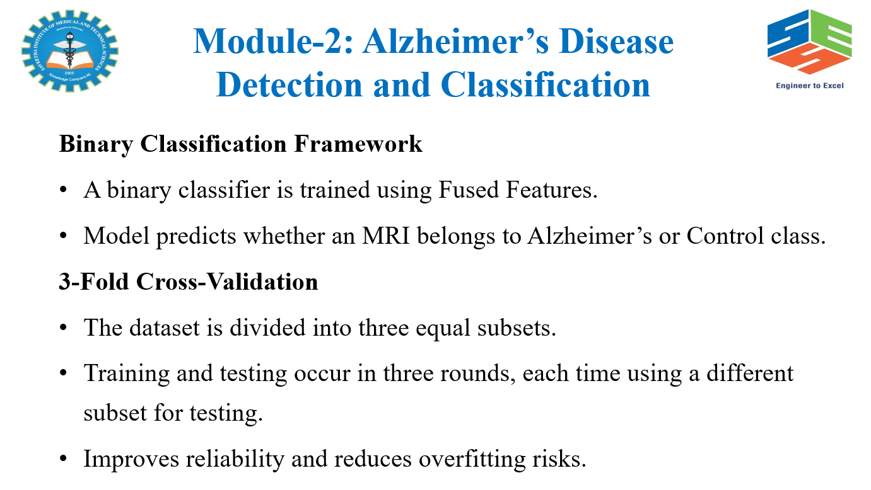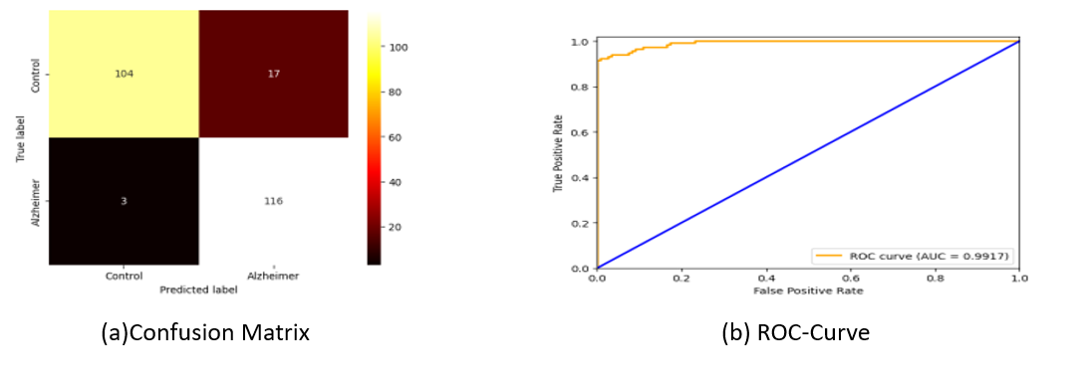
Project Description:
The design and implementation of a system for Examination of Brain MRI Slices to Detect Alzheimer’s Disease plays a very important role in assisting early diagnosis and reducing manual workload for doctors. Alzheimer’s Disease is a neurological disorder that causes memory loss and cognitive decline. Manual examination of MRI scans can be time-consuming and may vary between experts. Therefore, an automated system helps in providing faster and more consistent results. The system is designed to accept raw brain MRI images as input. Initially, it performs essential preprocessing steps such as noise removal, image normalization, resizing, and contrast enhancement. These steps improve image quality and ensure that all MRI slices are in a standard format. The system may also perform skull stripping to remove non-brain tissues, helping focus only on relevant brain regions. After preprocessing, the system extracts important features from the MRI images. These features may include texture patterns, intensity variations, and structural changes in specific brain regions like the hippocampus, which is commonly affected in Alzheimer’s patients.

Student Signature Guide Signature

